ONELINK QUARTERLY REPORT ENDING DECEMBER 2019
What is One Link?
OneLink is a central intake and assessment service. This means that it assesses all requests for support (accommodation and services) and does not turn eligible people away. It then prioritises people according to their needs, refers immediately where possible or places them on an active waiting list.
On 1 July 2016, OneLink combined the previous homelessness gateway (First Point) and the Child Youth and Family Services Gateway, as well as providing access to a range of mainstream services.
How does it work?
People can access OneLink through a 1800 number (1800 176 468), in person at Nature Conservation House, at Outreach locations or via the Onelink Website (www.onelink.org.au/services) through webchat.
OneLink does not provide direct client support – it assesses and records a person’s needs, maintains engagement through active holding and connects people to the supports they require.
When a person calls or visits OneLink, an Assessment and Support Officer assesses and prioritises the client’s needs, provides information about options and, where appropriate, follows up with clients to connect them to support. The Assessment and Support Officer will stay in touch with clients until they have all the supports they need.
At the end of the month OneLink reports on the number of people still waiting to be connected to any service, both accommodation and non-accommodation supports. Some people waiting at the end of the month may have had some service needs met while still waiting for connection to others.
Note: not all people waiting for accommodation are sleeping rough. Most are staying with relatives or friends or in other temporary accommodation (e.g. caravan parks, hostels etc).
What supports does OneLink connect people with?
Accommodation
- Short term emergency accommodation
- Transitional accommodation

Support services
- Housing support
- Assertive outreach
- Access to independent housing
- Support to sustain tenancy
- Youth and family support
- Youth support
- Family and child support
- Other support
- Aged care support
- Counselling services
- Disability support services
- Domestic and family violence support services
- Financial counselling
- Legal services
- Mental health services
- Health/medical services
- Drug/alcohol support
- Domestic assistance

What does this latest report show?
- OneLink supported a similar number of clients per month (623) in this quarter compared to the previous quarter (626).
- Lower number of new clients (on average 130 new client per month), lower than the number in previous quarter (158 during July – September 2019), but similar to the 131 in corresponding quarter in 2018. New clients represented around 21% of all clients each month.
- Higher number of occasions of one-off assistance (on average 263 occasions of one-off assistance per month in this quarter compared with 185 in the previous quarter), but consistent with the 255 in the corresponding quarter in 2018.
- Clients waited longer for accommodation (32.6 days in this quarter compared with 29.6 days in previous quarter) but shorter for support services (28.1 days in this quarter compared with 29.5 days in previous quarter).
- Lower number of clients placed into accommodation, but higher number of clients provided with support services in this quarter. 113 clients were placed into accommodation and 239 provided with support services in this quarter compared with 132 and 197 respectively in the previous quarter.
- Lower number of clients on the waiting list at the end of each month (on average 301 clients in this quarter). This is lower than 313 clients in the previous quarter (July-September 2019), but higher than 185 clients during the corresponding quarter in 2018.
- People experiencing family and domestic violence remain the single largest group seeking support.
- The majority of non-accommodation placements (55.0%) were for those clients seeking housing support (i.e. support to sustain their tenancy, access to independent housing); slightly lower than the proportion in the last quarter (56.3%).
- Weekend service: the trial of weekend service since April 2019 was completed by the end of December 2019. A range of client engagement strategies were tested during this trial including basing staff Southside at Woden Community Service (WCS), Corinna Street office. A central location was also established with the Red Cross Road House. This has been very successful and has offered another face to face engagement opportunity while allowing OneLink staff to build rapport and trust with people visiting the Red Cross Road House. As of 2 January 2020, the weekend service delivery has become an essential part of OneLink’s business model. The timeframe is as bellows:
- Saturday: 12:30 to 5:00 pm at Woden Community Service, 26 Corinna Street
- Sunday: 12:15 pm to 3:30 pm at WCS office at 26 Corinna Street
4 pm to 5:00 pm at Red Cross Roadhouse, Civic.
- OneLink Complex:
- OneLink Complex is a specialist engagement service working with a cohort of clients with complex referral pathways
- When conventional referral pathways are not appropriate through OneLink usual processes, a referral is made to OneLink Complex.
- A complex referral pathway is when there are barriers to accessing the service system, for example, people who are not referral ready, are not eligible for current services, or have exhausted their options within the sector etc.
- This quarter OneLink Complex provided intensive support to 29 OneLink clients to achieve desired outcomes.

ONE LINK QUARTERLY REPORT ENDING DECEMBER 2019
Number of clients  - OneLink supported an average 623 clients each month during this quarter (October, November, and December 2019). This is higher than the 465 average for the same quarter in 2018.  - OneLink supported a total of 390 new clients during the October to December 2019 period, similar to 393 in the same period in 2018.  - OneLink provided an average of 263 one-off assistance each month in this quarter, higher than 185 in the previous quarter. | 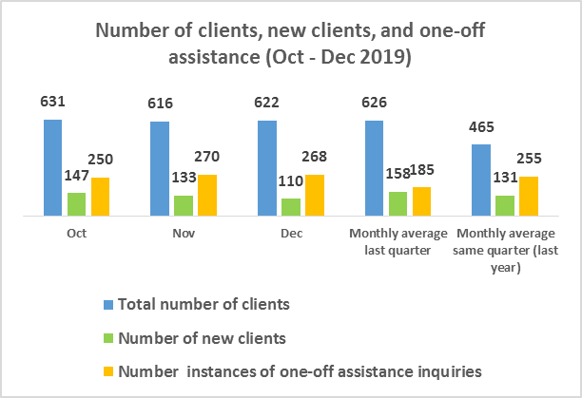
New clients by priority groups  - Of all new clients the largest single priority group was those experiencing family and domestic violence (on average 25.1% of new clients).  Note this graph is reflective of the top four priority groups and does not capture all new clients. | 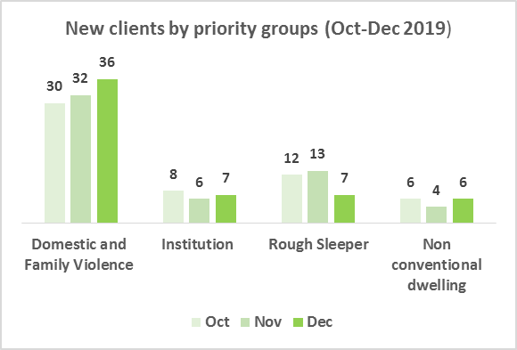
New clients by demography  - There were more new female clients (on average 57.9%) than new male clients (42.1%).  - Aboriginal and Torres Strait Islander people accounted for 6.4% of new clients.  - Young people accounted for 23.8% of all new clients. | 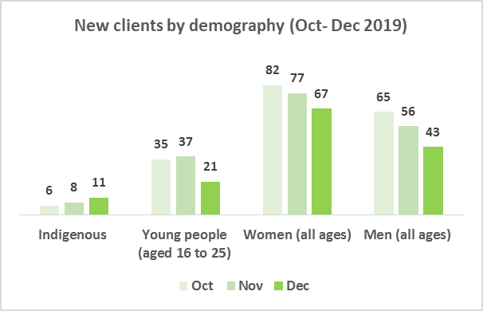
Number of clients placed into accommodation and support services  - A total of 113 clients were placed into accommodation with an average of 38 clients placed each month.  - A total of 239 clients were placed into support services with an average of 80 clients placed each month. | 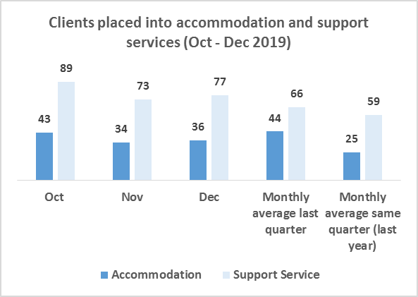
Placement by Support Service  During this quarter, there were a total of 282 placements into support services:  - 55.0% (155) provided by housing support services, which provide tenancy support, assertive outreach, access to independent housing.  - 13.5% (38) provided by youth and family support services.  - 31.6% (89) provided by other support services including legal, mental health, family and domestic violence, financial assistance, disability support, and counselling services, drug, alcohol service.  Note: number of clients and number placements are different; some clients are provided with more than one placement to meet their different needs. | 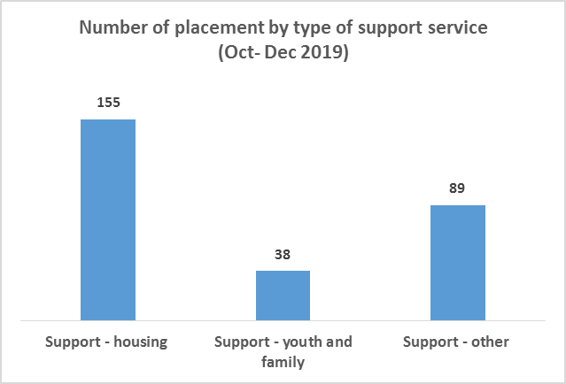
Waiting time for accommodation and support services  During this quarter, clients waited on average 28.1 days for support services (29.5 days in the last quarter), and 32.6 days for placement into accommodation (29.6 days in the last quarter).  Note that ‘waiting for accommodation’ does not necessarily equate to rough sleeping. Many people are staying with friends or relatives or other temporary accommodation. | 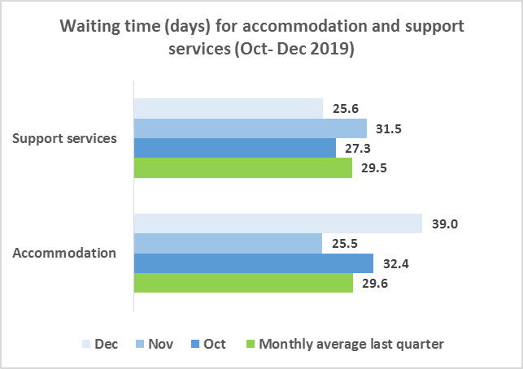
Waiting time by type of support service  During this quarter, clients waited on average:  - 33.1 days for placement into housing support (33.6 days in the last quarter).  - 21.7 days for youth and family support (31.2 days in the last quarter).  - 22.0 days for other support (18.9 days in the last quarter). | 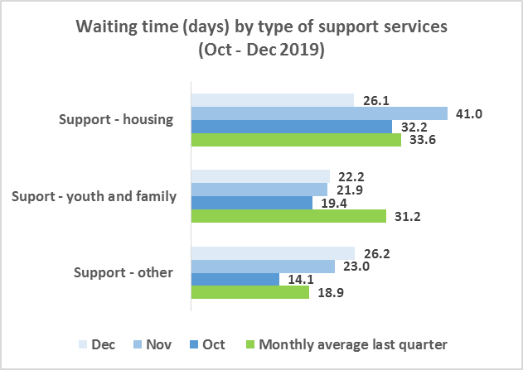
Waiting list  - At the end of December 300 clients were waiting for accommodation and/or support services.  - This is consistent with the average of 301 over the 3 month period.  Note: clients at end of month may be connected to some services but are waiting connection to others. | 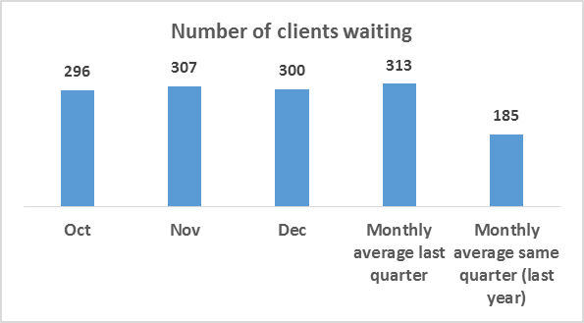
Key terms explained
Client | A client refers to any person who directly receives a service. For example, if a mother and three children require accommodation, and OneLink only has contact with the mother, then the mother will be the only client for OneLink, with other family members not directly assisted. If referred to a service that then accommodates the family, then that service provides direct service for the mother and the children and that service will count each member of the family as clients.
One-off assistance  *people receiving one-off assistance are not counted as client | Provision of immediate support, including providing information and clarification, where there is no need for continued assistance at the time of the enquiry.
Rough sleeper | A person who is living on the streets, sleeping in parks
Non-conventional dwelling | A person who is a squatter or who is living in an improvised dwelling (tent, car etc.)
Assistance to access independent housing | Provision of support to clients to obtain an independent tenancy, including private, community and public housing.  Services include:  - Supportive Tenancy Service – housing options  - ASSIST (Catholic Care)  - Youth Housing Support Service(Catholic Care)  - St Vincent de Paul’s (SVDP) Family Service and Young Parents Program  - Everyman Australia  - YWCA Canberra;  - Karinya  - Northside Community Service  - Ted Noffs Take Hold
Tenancy support | Provision of support to clients to maintain an existing tenancy (e.g. Supportive Tenancy Service – tenancy support)
Short term or emergency accommodation | Short term accommodation with support to help address any issues leading to homelessness and seek an independent tenancy. Services are targeted to particular population groups or needs, including single men (e.g. Samaritan House, CatholicCare Minosa ), young people (Youth Emergency Accommodation Network (YEAN)), women and families (Toora) and women leaving domestic violence (e.g. Beryl, Doris)
Transitional accommodation | Medium term accommodation with limited support focussed on finding long-term accommodation, for people who have the capacity to maintain a tenancy. Funded transitional accommodation includes SDVP’s Family Service, YWCA Canberra’s Housing Support Unit, Banardo’s Our Place and Friendly Landlord programs, Everyman, Northside Community Service and Karinya.

Assertive outreach for rough sleepers | Outreach services to assist people who are sleeping rough or in non-conventional dwellings, to assist in connection to services as needed (e.g. SVDP’s Street to Home program)
Financial assistance/ material aid | Emergency relief, such as food, clothing or assistance with expenses (e.g. SVDP, Salvation Army and Uniting Care Kippax)
Domestic/family violence support | Support specifically around responding to the experience of domestic or family violence e.g. Domestic Violence Crisis Services; note other services (including Beryl, Doris, YWCA Canberra and Toora Women) provide domestic and family violence support as part of emergency accommodation
Youth Support | Support for young people, up to 25 years of age e.g. Youth Engagement Teams and YouthCARE Canberra
Family/child support | Support for families and/or children, including family case management services
Disability support (including NDIS) | Support for people living with a physical or intellectual disability, including services under NDIS or CASP other than domestic assistance – excludes psychosocial disability.
Domestic assistance/CASP | Support for domestic assistance or through CASP, which provides assistance to people who do not qualify for or have not yet obtained NDIS support (domestic assistance is often provided through CASP)
Aged care support | Support for older people (generally 65 years or older), including through My Aged Care
Health/ medical services | Medical support e.g. Through General Practitioners, Winnunga
Mental health services | Support for people living with a psychosocial disability, including through NDIS, as well as other specific mental health services
Counselling services | Professional assistance to promote mental health and wellbeing, enhance self-understanding, and resolve identified concerns (e.g. Relationships Australia)
Drug/alcohol support | Support for people dealing with addiction to alcohol or other drugs (e.g. Directions ACT, Karralika)
Legal issues/court support | Legal advice or assistance through legal processes (e.g. Canberra Community Law, Tenants Union, Street Law, Legal Aid)
Financial counselling | Information, support and advocacy to assist people in financial difficulty (e.g. Care Financial)
Other | Support not covered in other categories, including general support for specific population groups (e.g. MARSS)

